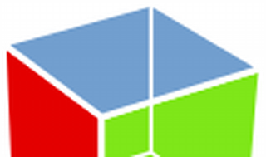

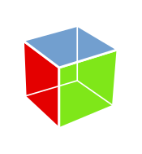

Explore

**GTK**, which stands for the **GIMP Toolkit**, is a **free and open-source cross-platform widget toolkit** used for creating graphical user interfaces (GUIs) in various programming languages. [It provides a comprehensive set of UI elements and is suitable for projects ranging from small tools to complete application suites1](https://www.gtk.org/)[2](https://docs.gtk.org/gtk4/overview.html).

Here are **five free resources** where you can learn more about GTK:

1. [**GTK Project Official Website**](https://www.gtk.org/): The official GTK website offers documentation, tutorials, and examples to get you started with GTK development[1](https://www.gtk.org/).
2. [**GTK Documentation**](https://www.gtk.org/docs/): Explore the official documentation to learn about GTK’s features, APIs, and how to create your first GTK application[3](https://www.gtk.org/docs/getting-started/index).
3. [**Getting Started with GTK**](https://www.gtk.org/docs/getting-started/index): Follow the “Hello World” tutorial and dive into GTK’s user interface elements and event-driven programming[3](https://www.gtk.org/docs/getting-started/index).
4. [**Dev Tools and Language Bindings**](https://www.gtk.org/docs/): Learn how to set up your development environment and integrate your favorite programming language with GTK using language bindings[4](https://www.gtk.org/docs/).
5. [**GUI Development with Rust and GTK 4**](https://gtk-rs.org/gtk4-rs/stable/latest/book/): If you’re interested in Rust, this resource provides guidance on using GTK with Rust programming[5](https://gtk-rs.org/gtk4-rs/stable/latest/book/).

Happy learning! 🌟